**Store the data set and see the number of samples with features.**

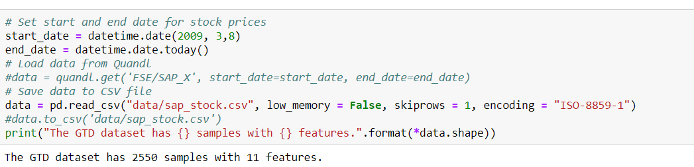

**Display the dataset 1st 5 rows.**

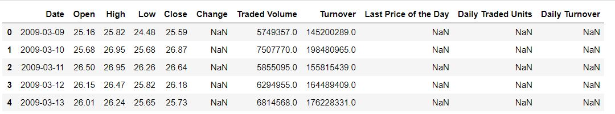

**Information features in a dataset**

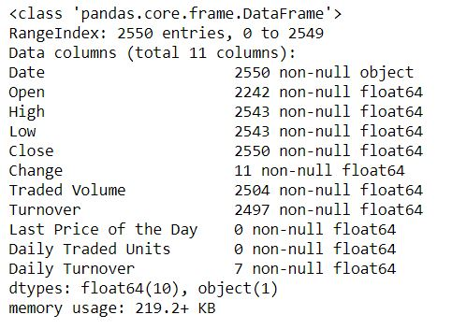

**Descriptive statistics summary of data set:**

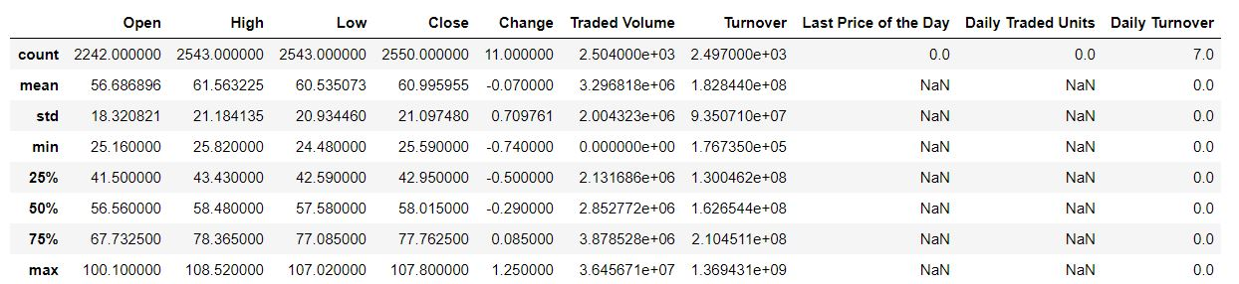

**Display features in data set:**

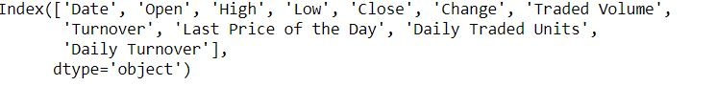

**Reset index column so that we have integers to represent time for later analysis:**

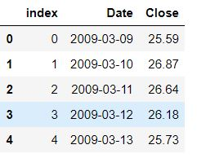

**Check data types in columns:**

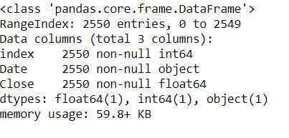

**Create subplots to plot graph and control axes:**

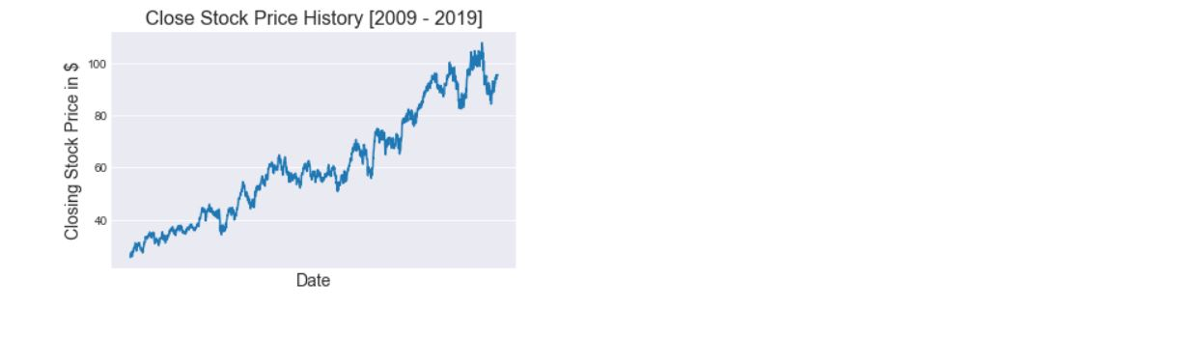

**Linear Regression: Using linear regression plot the data:**

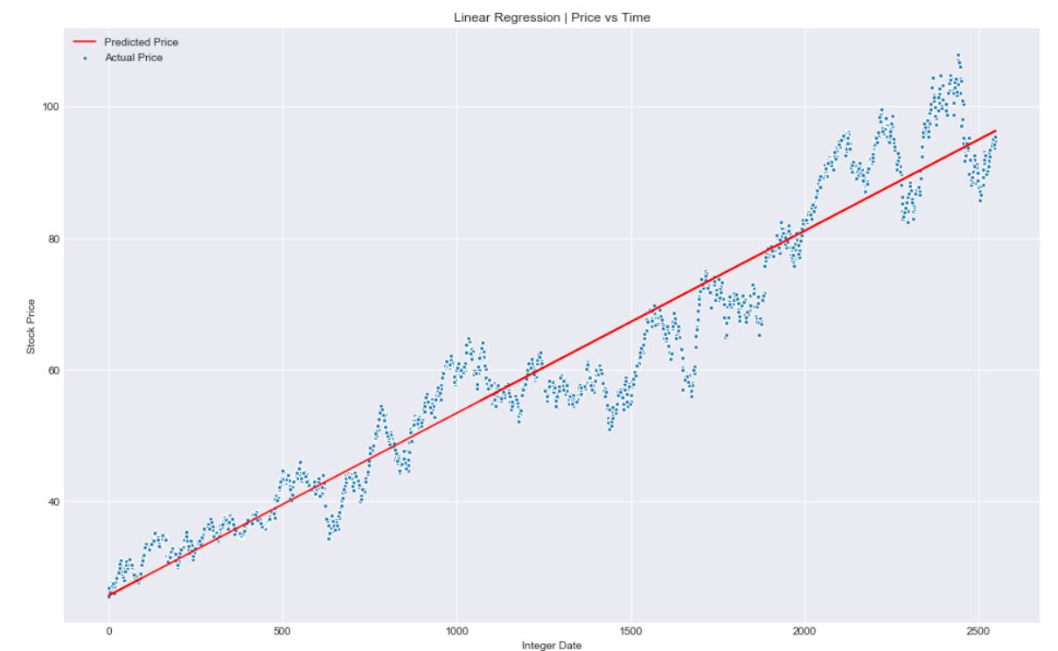

**Generate array with predicted values:**

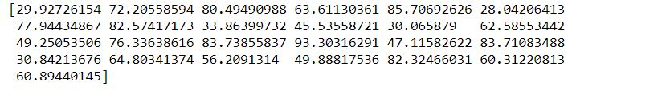

**Display the details:**

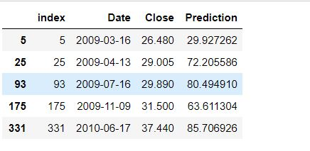

**Comparison Predicted vs Actual Price in Sample data selection:**

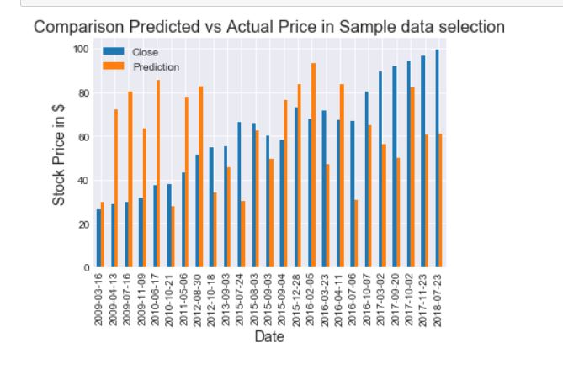

**Price vs. Time Future:**

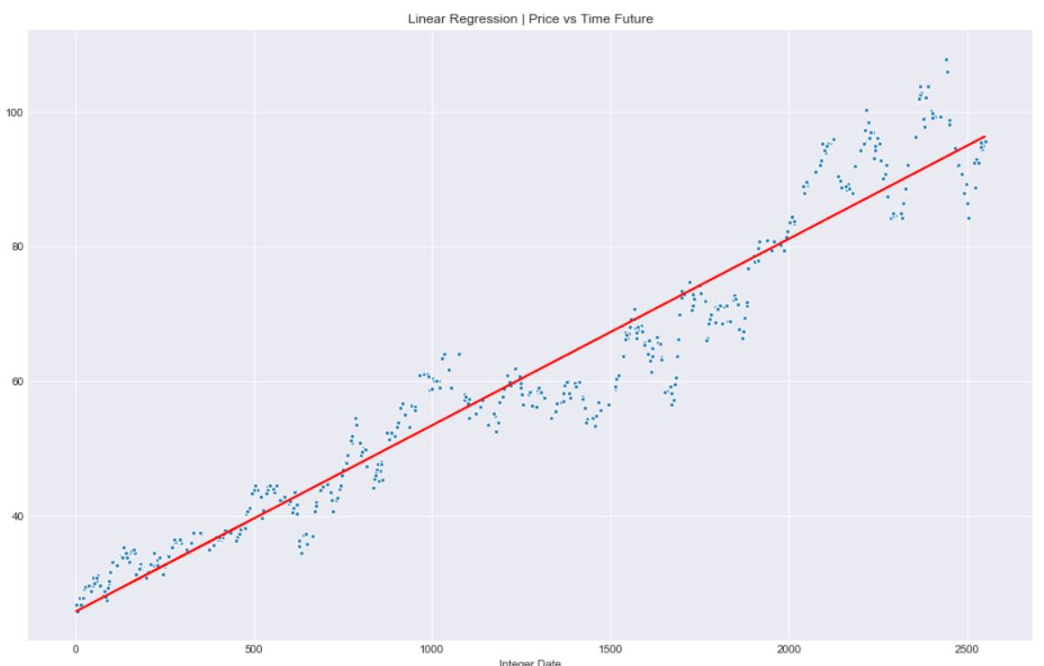

**Predicted Actual Price in future:**

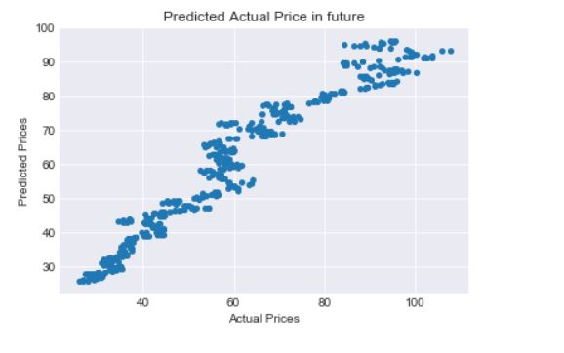

**Residual Histogram & Distribution:**

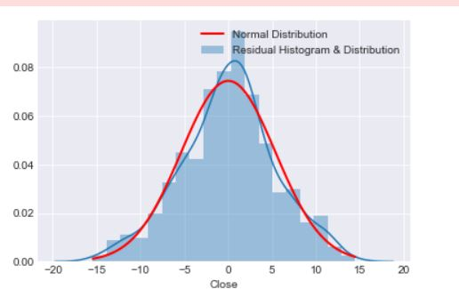

**Add new column for predictions to df:**

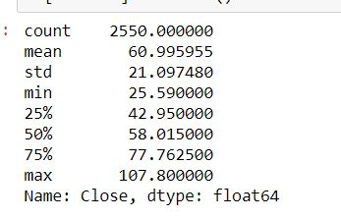

**The value of R2 shows that are model accounts for nearly 94% of the differences between the actual stock prices and the predicted prices:**

